**Lab 1**

**Question 1**

You are asked to build a webpage to show the current date. The user can access your page via url: **/email**

Your Tasks include:

* When the user access /email for the first time, the system displays the form as below figure.

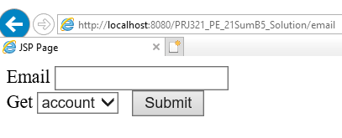

Figure 1 – The page on first visit

The dropdown list has two items as figure below

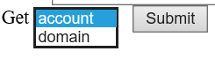

Figure 2 – Items of the dropdown list.

* When the user clicks [Submit] button, the system display account or domain part of the entered email depending on the selected item of dropdownlist.

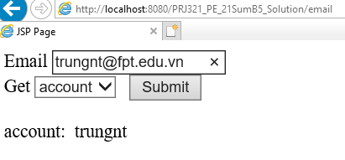

Figure 3 – The page is displayed after user choose “account” and then

click on button Submit.

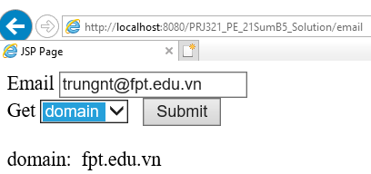

Figure 3 – The page is displayed after user choose “domain” and then

click on button Submit.

**Question 2**

The login form must like the Figure below:

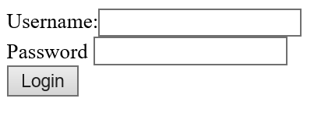

* User enters existed username and password in Account table, the system then performing authentication. If username or password is invalid, show message “Login failed” below the form. If the login is successful, redirect user to the URL /rooms.
* If user access the required-authenticated feature URL without authentication. The system redirects the user to Authentication page at /login**.**